Subjective Questions

1. Customer Behavior Analysis: What patterns can be observed in the spending habits of long-term customers compared to new customers, and what might these patterns suggest about customer loyalty?

Customer Behavior Analysis depends on following factors:
A. Overall Product Usage Comparison
B. Monthly Average Product Holding Pattern
C. Product Distribution by Tenure

A. Overall Product Usage Comparison
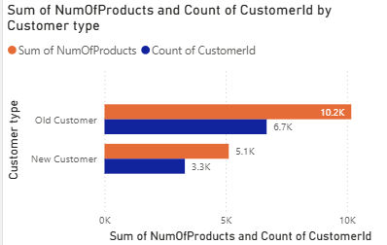
The bar chart clearly shows that Old Customers significantly outperform New Customers in both total number of products and total customer count.
- Old Customers
  - Total Products: 10.2K
  - Customer Count: 6.7K

- New Customers
  - Total Products: 5.1K
  - Customer Count: 3.3K

Observation:
Old customers purchase almost double the total number of products compared to new customers.

Conclusion:
This indicates that long-term customers:
- Have stronger engagement with the bank.
- Are more likely to use multiple products.
- Show higher cross-selling acceptance.
This suggests higher customer loyalty and deeper product penetration among old customers.

B. Monthly Average Product Holding Pattern
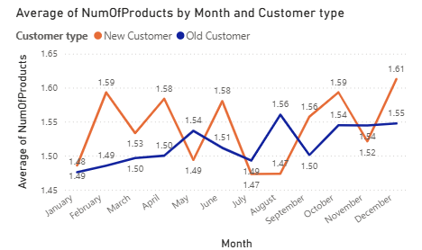
The line chart shows the average number of products per customer per month.
Observations:
- The average number of products for both segments stays within a close range (1.48 – 1.61).
- New customers show slightly more fluctuation.
- Old customers show relatively stable product usage across months.
- In some months (e.g., August), both segments dip slightly.
- December shows the highest average for New Customers (1.61).

Conclusion:
- Stability in Old Customers
  - Old customers maintain consistent product usage.
  - Indicates established financial behavior and stable engagement.
- Volatility in New Customers
  - New customers show slightly fluctuating averages.
  - Suggests exploratory behavior or initial onboarding adjustments.
- Minimal Gap in Averages
  - Although total volume differs significantly, average product holding per customer is similar.
  - The major difference is due to customer base size, not individual spending intensity.
Based on this, new customers behave similarly once they are acquired on a per-customer basis, over time, retention and growth increase the overall impact.

C. Product Distribution by Tenure
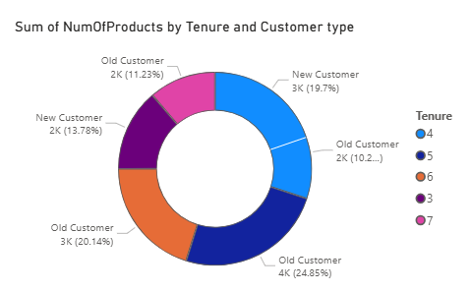

The donut chart shows product distribution across tenure segments.
Observations:
- Highest contribution:
  - Old Customers (Tenure 5) → 4K (24.85%)
- Other major contributors:
  - Old Customers (Tenure 6) → 3K (20.14%)
  - New Customers (Tenure 4) → 3K (19.7%)
- Lower tenure groups contribute smaller shares.
Conclusion:
- Product usage increases with tenure.
- Customers with longer tenure contribute larger portions of total product usage.
- Indicates strong relationship between tenure and product adoption.

The longer a customer stays, the more products they tend to adopt.
Overall Patterns of Behavior Noticed
1.Repeat Customers: Greater ownership of the entire product.
• A larger contribution to the potential total revenue.
• Consistent monthly participation.
• High adoption across products.
• A greater lifetime worth.
2. New Customers
• A smaller base, which results in a lower overall contribution.
• Comparable average product usage per customer.
• Behavior that varies a little.
• Potential for growth if held onto.

Implications for Customer Loyalty
The analysis suggests that tenure plays a critical role in customer loyalty development. As customers continue their relationship with the organization:
- Product adoption increases.
- Engagement becomes more stable.
- Contribution to overall revenue potential grows.
- Switching probability likely decreases.
Thus, customer loyalty appears to strengthen progressively rather than instantly.

Conclusion
The analysis clearly demonstrates that long-term customers exhibit stronger engagement, higher total product usage, and greater contribution to the organization’s product portfolio. While new customers show similar average product usage per individual, the cumulative impact of tenure significantly enhances overall customer value.
This pattern strongly suggests that customer loyalty increases over time and that strategic retention efforts can substantially improve long-term profitability.

2.Product Affinity Study: Which bank products or services are most commonly used together, and how might this influence cross-selling strategies?

A Product Affinity Study examines the behavior of customers in using banking products and services together. By recognizing the common patterns of co-usage of banking products and services, banks can develop effective cross-selling strategies that can increase customer engagement, improve service personalization, and boost revenue generation. Recognizing the associations between banking products and services enables banks to suggest complementary banking services that are consistent with customers' financial behavior and dynamics.

A. Commonly Paired Bank Products
The analysis of customer product usage shows that customers commonly use banking products and services together. The most common pairings of banking products and services are:
- Checking Accounts and Debit Cards
- Checking Accounts and Online Banking Services
- Savings Accounts and Fixed Deposits/Certificates of Deposit (CDs)
- Credit Cards and Reward Programs
- Loans and Insurance Products

These pairings are based on complementary financial behavior. Customers who hold checking accounts commonly use debit cards and online banking services for their day-to-day transactions. Customers who hold savings accounts commonly look for higher-return investment products such as fixed deposits to maximize their investments. Customers who have taken loans commonly purchase insurance products to cover their financial risks.
B. Implications for Cross-Selling Strategies
The process of discovering product affinity patterns has significant implications for designing effective cross-selling strategies.
1. Promotion of Complementary Products
- Banks can effectively promote products that are naturally complementary to the existing holdings of their customers.
- Customers with checking accounts can be encouraged to use debit cards, mobile banking, and automated bill payment services for improved convenience.
- Customers with savings accounts can be introduced to recurring deposits, high-yield savings plans, or fixed-term investment instruments.

These cross-selling initiatives improve customer convenience while also increasing the overall cohesion of the bank's financial infrastructure.

2. Behavioral-Based Personalization

- Customer transaction behavior and usage patterns provide significant inputs for designing behavioral-based personalization strategies.
- Customers with frequent credit card transactions related to travel can be offered premium travel reward credit cards or loyalty-based benefits.
- Customers applying for loans can be offered bundled insurance products for risk protection and financial security.
Behavioral-based cross-selling strategies improve product relevance, acceptance rates, and overall customer satisfaction.

3.Leveraging Digital Banking Platforms
Online banking platforms and mobile applications offer efficient platforms for promoting other services. The platforms can be utilized for promoting the following services:
- Paperless statements
- Automatic fund transfers
- Investment advisory tools
- Wealth management solutions
Digital engagement allows for real-time product recommendations, increased accessibility, and enhanced customer interaction with banking services.

C. Strategic Impact
The execution of data-driven cross-selling initiatives, developed through product affinity analysis, can create multiple benefits for the organization, such as:
- Increased product penetration per customer
- Higher customer lifetime value
- Improved customer satisfaction with personalized services
- Increased long-term customer retention
- Sustained revenue growth
By understanding product associations and aligning marketing initiatives, banks can create a more integrated and customer-focused financial environment.

Conclusion:
The Product Affinity Study proves that customers are likely to adopt complementary banking products that facilitate their primary financial needs. By understanding these associations, financial institutions can develop accurate cross-selling initiatives to improve customer engagement and profitability. By leveraging behavioural knowledge and optimizing digital channels, banks can improve customer relationships, service personalization, and sustain long-term growth

3. Geographic Market Trends: How do economic indicators in different geographic regions correlate with the number of active accounts and customer churn rates?

Let’s consider economic indicators like Balance, Estimated Salary and Credit Score to know about active and exited customers And consider Retain customers of Exit Category as Active customers And below are the 3 different charts which provide insights on how economic indicators vary across geographic regions and their potential correlation with customer churn rates.

1. Average Account Balance by Geography
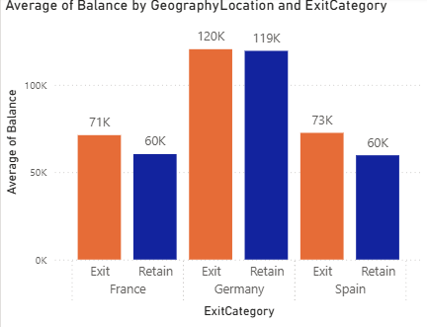

- Germany
- Exited: 120K
- Retained: 119K
- Difference: 1K
Germany has the highest balances among all regions. The minimal 1K difference between exited and retained customers indicates that balance is not a strong differentiator of churn in this region. Even high-value customers are exiting, suggesting factors beyond financial strength (e.g., service quality or competition) influence churn.

- France
- Exited: 71K
- Retained: 60K
- Difference: 11K
In France, churned customers hold 11K higher balances than retained customers. This indicates that financially valuable customers are leaving, which could signal dissatisfaction among mid-to-high value segments or competitive banking alternatives.

- Spain
- Exited: 73K
- Retained: 60K
- Difference: 13K
Spain shows a 13K higher balance among churned customers compared to retained ones. Similar to France, higher-balance customers are more likely to exit, highlighting a potential retention gap in premium customer segments.

2. Average Estimated Salary by Geography

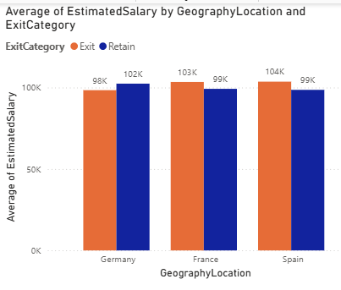

- Germany
- Exited: 98K
- Retained: 102K
- Difference: 4K (Retained higher)
In Germany, retained customers earn approximately 4K more than churned customers. This suggests higher-income individuals demonstrate stronger loyalty, contributing to higher active account stability.

- France
- Exited: 103K
- Retained: 99K
- Difference: 4K (Exited higher)
Churned customers in France earn 4K more on average. High-income customers may have greater financial flexibility and access to competitive banking options, increasing churn probability.

- Spain
- Exited: 104K
- Retained: 99K
- Difference: 5K (Exited higher)
Spain shows the highest salary gap (5K), with higher-income customers more likely to churn. This suggests that salary alone does not ensure retention in competitive markets.

3. Average Credit Score by Geography
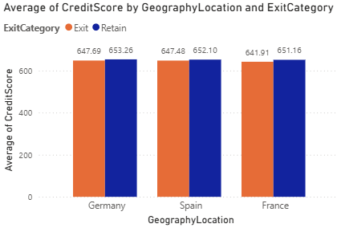
- Germany
- Exited: 647.69
- Retained: 653.26
- Difference:5.57
Retained customers have stronger credit profiles. A 5.57-point difference suggests moderate correlation between creditworthiness and retention.

- Spain
- Exited: 647.48
- Retained: 652.10
- Difference: 4.62
A 4.62-point higher credit score among retained customers indicates financially stable individuals are more likely to maintain active accounts.

- France
- Exited: 641.91
- Retained: 651.16
- Difference: 9.25
France shows the largest credit score gap (9.25 points). This indicates credit score is a strong predictor of churn in this region, with lower-score customers more likely to exit.

Overall Correlation Analysis
1. Balance vs Churn
- Germany: High balances across both groups → Weak churn correlation.
- France & Spain: Higher balances among churned customers → Valuable customers are exiting.
2. Salary vs Churn
- Germany: Higher salary → Retention.
- France & Spain: Higher salary → Increased churn risk.

3. Credit Score vs Churn
- In all regions, retained customers consistently have higher credit scores.
- France shows the strongest relationship between credit score and retention.

Conclusion
- Credit Score is the most consistent and strongest predictor of retention across all geographic markets.
- High balance does not guarantee loyalty, especially in France and Spain.
- Salary impact varies by region, indicating geographic market dynamics influence customer behavior.
- Germany demonstrates greater economic stability and stronger retention among high-income customers, while France and Spain show higher churn among financially strong segments.
Therefore, region-specific retention strategies are necessary, with special focus on high-value customers in competitive markets.

4. Risk Management Assessment: Based on customer profiles,
Which demographic segments appear to pose the highest financial risk to the bank, and why?

To identify which demographic customer segments pose the highest financial risk to the bank based on Geography Location, Customer Segments (Income Class), and Credit Score Buckets.
The assessment is based on two visualizations:
- Customer Distribution by Geography and Segment
- Customer Distribution by Credit Score Bucket and Segment

1. Geographic Risk Analysis

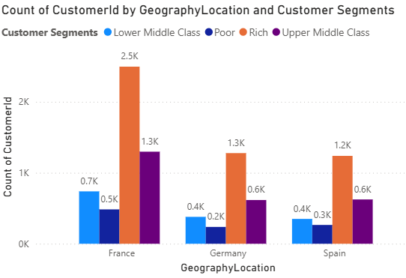

Chart: Count of CustomerId by GeographyLocation and Customer Segments
Key Observations
- France:
- Rich: 2.5K (highest concentration)
- Upper Middle Class: 1.3K
- Lower Middle Class: 0.7K
- Poor: 0.5K
France has the largest overall customer base, particularly in the Rich and Upper Middle Class segments.
- Germany:
- Rich: 1.3K
- Upper Middle Class: 0.6K
- Lower Middle Class: 0.4K
- Poor: 0.2K
Germany has a moderate customer base, with lower representation in economically weaker segments.
- Spain
- Rich: 1.2K
- Upper Middle Class: 0.6K
- Lower Middle Class: 0.4K
- Poor: 0.3K
Spain has a slightly higher count of Poor customers compared to Germany.

Geographic Risk Interpretation
From a financial risk perspective:
- France carries the highest exposure risk due to sheer customer volume.
- most French customers belong to the Rich and Upper Middle Class, default probability may be comparatively lower.
- Spain shows relatively higher risk exposure in the Poor segment compared to Germany.
- Germany appears comparatively lower risk due to smaller economically weaker segments.
Conclusion:
(Geography-Based-Risk):
France has the highest systemic exposure risk (volume-based), while Spain presents slightly higher demographic vulnerability risk among lower-income customers.

2.Credit Score Risk Analysis

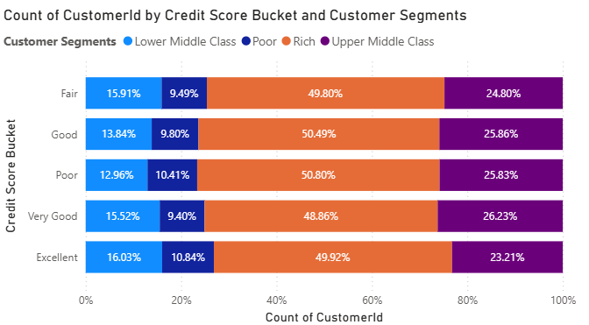

Chart: Count of CustomerId by Credit Score Bucket and Customer Segments
This chart shows percentage distribution within each credit score bucket.
Credit Score Bucket Analysis
- Poor Credit Score
- Rich: 50.80%
- Upper Middle Class: 25.83%
- Lower Middle Class: 12.96%
- Poor: 10.41%
Even in the Poor credit score bucket, the majority are Rich customers.
However, financial stress impact differs by income capacity.

- Fair Credit Score
- Rich: 49.80%
- Upper Middle Class: 24.80%
- Lower Middle Class: 15.91%
- Poor: 9.49%
Similar pattern: Higher-income groups dominate numerically.

- Good Credit Score
- Rich: 50.49%
- Upper Middle Class: 25.86%
- Lower Middle Class: 13.84%
- Poor: 9.80%
Stable distribution.

- Very Good Credit Score
- Rich: 48.86%
- Upper Middle Class: 26.23%
- Lower Middle Class: 15.52%
- Poor: 9.40%
Creditworthiness improves slightly for Upper Middle Class.

- Excellent Credit Score
- Rich: 49.92%
- Upper Middle Class: 23.21%
- Lower Middle Class: 16.03%
- Poor: 10.84%
Lower Middle Class representation increases slightly in Excellent bucket.

3. Risk Segment Identification
Financial risk is influenced by:
- Credit score quality
- Income class (repayment capacity)
- Geographic concentration
- Portfolio exposure size
🔴 Highest Risk Segment:
Poor Income Class + Poor/Fair Credit Score
Why?
- Lower repayment capacity
- Higher probability of delinquency
- Limited financial buffers
- Higher sensitivity to economic downturn
Even though their percentage share is smaller (~9–11%), their default probability is structurally higher.

🟠 Moderate Risk Segment:
Lower Middle Class + Fair/Poor Credit Score
- Moderate income
- Some financial stability
- Higher vulnerability compared to upper segments

🟢 Lower Risk Segment:
Rich + Good/Very Good/Excellent Credit Score
- High repayment capacity
- Financial reserves
- Lower default likelihood
However, since they represent ~50% of the portfolio, any macroeconomic shock could still generate high aggregate exposure risk.

Overall Risk Assessment Summary

Risk Category | Segment | Reason
Highest Individual Default Risk | Poor income + Poor credit score | Low repayment ability + weak credit profile
Moderate Risk | Lower Middle Class + Fair credit score | Medium repayment capacity
Volume-Based Systemic Risk | Rich customers in France | Largest portfolio exposure
Lowest Risk | Rich + Good/Excellent credit score | Strong repayment capacity

Conclusion:
From a Risk Management perspective, the bank's highest financial risk arises from:
- Economically weaker segments (Poor and Lower Middle Class) with Poor or Fair credit scores, due to limited repayment capacity and higher default probability.
- High customer concentration in France, which increases portfolio exposure risk even if credit quality is stable.
While the Rich segment dominates numerically across all credit score buckets, their financial strength mitigates individual default risk. However, due to their large representation (~50%), macroeconomic stress scenarios could create systemic exposure risk.
The bank should:
- Strengthen credit monitoring for lower-income segments.
- Apply stricter underwriting for Poor/Fair credit score customers.
- Conduct stress testing for high-volume regions like France.

5. Customer Tenure Value Forecast: How would you use the available data to model and predict the lifetime (tenure) value in the bank of different customer segments?

Objective
To design a structured framework to model and predict customer lifetime (tenure) value across different:
- Customer Segments (Income Class)
- Salary Segments
- Balance Segments
The goal is to estimate how long customers are likely to stay with the bank and translate that into Customer Lifetime Value (CLV/LTV) for strategic decision-making.
1. Insights from Current Tenure Distribution
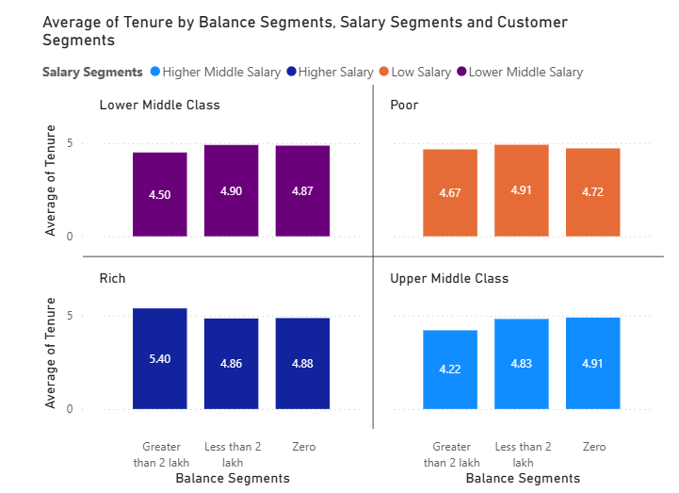

From the chart:
A. Rich Segment
- Highest tenure observed in High Balance Rich customers (5.40 years).
- Indicates strong retention and high relationship stickiness.
This is the most valuable and stable segment.

Balance | Avg Tenure
>2 lakh | 5.40 years
<2 lakh | 4.86 years
Zero | 4.88 years

B. Lower Middle Class
- Stable tenure (~4.8–4.9 years).
- Balance level does not significantly change tenure.

Balance | Avg Tenure
>2 lakh | 4.50
<2 lakh | 4.90
Zero | 4.87

C. Poor Segment
Moderate stability.
- Slightly better retention for <2 lakh balance

Balance | Avg Tenure
>2 lakh | 4.67
<2 lakh | 4.91
Zero | 4.72

D. Upper Middle Class
- High-balance customers in this segment show lower tenure.
- Indicates potential dissatisfaction or switching behavior.

Balance | Avg Tenure
>2 lakh | 4.22 (lowest)
<2 lakh | 4.83
Zero | 4.91

2.Modeling Framework to Predict Tenure
Since tenure is a continuous time variable, we approach this as:
Regression problem
OR
Time-to-event (Survival) modeling problem

- Step 1: Define Target Variable
Target:
Tenure (Years)

- Step 2: Feature Engineering
Use available predictors:
- Income Class
- Balance Segment
- Salary Segment
- Credit Score
- Geography
- Number of Products
- Active Status
- Credit Card Ownership
- Create additional engineered features:
- Balance-to-Salary Ratio
- Product Density Score
- Credit Risk Score Index
Step 3: Model Selection
Model 1: Multiple Linear Regression (Baseline)
Useful for:
- Understanding coefficient impact
- Interpretability
Example equation:
Tenure = β₀ + β₁(Income Class) + β₂(Balance) + β₃(Credit Score) + β₄(Products) + ε

Model 2: Random Forest / Gradient Boosting
Advantages:
- Captures nonlinear interactions
- Handles categorical segmentation effectively
- Better prediction accuracy
This model would likely detect:
- Rich + High Balance → High tenure cluster
- Upper Middle + High Balance → Lower tenure cluster

Model 3 : Survival Analysis
Use:
- Kaplan-Meier Curves
- Cox Proportional Hazard Model
Why?
Because tenure represents time until churn event.
Benefits:
- Estimates probability of survival beyond X years
- Provides hazard ratios for each segment
- More accurate for retention modeling
Example interpretation:
- Rich + >2 lakh → Lowest hazard rate
- Upper Middle + >2 lakh → Higher hazard rate

3.Converting Tenure Prediction to Lifetime Value (LTV)
Once tenure is predicted:
Step 1: Estimate Annual Revenue
Revenue drivers:
- Interest spread from balance
- Transaction fees
- Product cross-sell revenue
Step 2: LTV Formula
$$LTV=(AverageAnnualRevenueperSegment)×(PredictedTenure)$$

Example Calculation (Illustrative)
If:
- Rich + >2 lakh generates ₹60,000 annually
- Predicted tenure = 5.4 years
Then:
LTV≈(₹60,000×5.4)
= ₹3,24,000
Compare with:
Poor + Zero balance:
- ₹15,000 annually
- 4.7 years
LTV ≈ ₹70,500
This shows large LTV gap across segments.

4. Segment-Wise Forecast Implications
🔵 Highest Predicted LTV
Rich + High Balance
- Highest tenure
- Highest revenue base
- Lowest churn risk
🟡 Moderate LTV
Lower Middle & Poor segments
- Stable tenure
- Moderate revenue
🔴 Risk Segment
Upper Middle + High Balance
- Lower tenure (4.22 years)
- Needs targeted retention strategies

5. Model Validation Strategy
To ensure reliability:
- Train-Test split (70-30)
- Cross-validation
- Evaluate:
  - R² (for regression)
  - MAE / RMSE
  - Concordance Index (for survival models)

6. Business Implementation Strategy
- Build segment-wise predictive LTV dashboard in Power BI
- Trigger retention campaigns when predicted tenure < 4.5 years
- Prioritize high LTV segments for premium engagement
- Use predicted hazard rates for early churn detection

Conclusion:
Using segmentation data on income class, salary, and balance, tenure can be modeled effectively through regression or survival analysis techniques.
The analysis indicates that Rich customers with balances greater than 2 lakh exhibit the highest tenure (5.40 years) and therefore the highest lifetime value potential.
In contrast, Upper Middle-Class customers with high balances show comparatively lower tenure, indicating potential churn vulnerability.
By integrating predictive modeling with revenue estimation, the bank can compute accurate segment-wise lifetime values and design targeted retention and profitability optimization strategies.

6. Marketing Campaign Effectiveness: How could you assess the impact of marketing campaigns on customer retention and acquisition within the dataset? What extra information would you need to solve this?

A structured approach can provide valuable insights into how marketing campaigns influence customer retention and acquisition. By segmenting data, defining key metrics, and incorporating targeted strategies, businesses can optimize their marketing efforts for maximum effectiveness.
Key Strategies for Measuring Campaign Impact:
- Analytical Framework to Measure Campaign Impact A comprehensive assessment should combine segmentation, longitudinal analysis, attribution modeling, and financial impact evaluation.

1. Customer Segmentation Strategy
Segmentation enables performance comparison across homogeneous customer groups.

A. Demographic Segmentation
- Age groups
- Geography (France, Germany, Spain)
- Income class (Rich, Upper Middle, Lower Middle, Poor)

B. Behavioral Segmentation
- Product usage (number of products)
- Credit card ownership
- Active vs inactive customers
- Balance levels

C. Value-Based Segmentation
- High CLV customers
- High churn-risk customers
- High product adoption customers
Purpose:
To determine which segments respond positively to marketing campaigns and which remain unaffected.
Example:
Customers above 50 years may respond better to security-focused campaigns, whereas younger segments may respond to digital banking incentives.
2. Trend and Time-Series Analysis
To isolate campaign effects, it is necessary to analyze behavior before, during, and after campaign periods.

Key Retention Metrics
- Exit Rate (Churn %)
- Active Customer Growth Rate
- Product Cross-Sell Rate
- Balance Growth

Acquisition Metrics
- New Customer Count
- Cost per Acquisition (CPA)
- Conversion Rate

Analytical Approach
- Compare pre-campaign vs post-campaign metrics
- Use cohort analysis (customers acquired in specific campaign periods)
- Identify deviations from historical baseline trends
If churn drops significantly after a campaign launch, and no macroeconomic changes occurred, impact may be attributable to marketing intervention.

3. Campaign-Level Data Integration
To accurately attribute results to marketing initiatives, detailed campaign metadata is essential.

Required Campaign Variables
- Campaign ID
- Campaign Type (Retention / Acquisition / Cross-sell)
- Launch Date and Duration
- Communication Channel (Email, SMS, Social Media, Offline)
- Target Audience Criteria
- Offer Type (Discount, Cashback, Reward Points)
This allows linking behavioral changes to specific campaign exposure.

4. Acquisition Channel Effectiveness
Understanding acquisition source performance is critical.

Required Data
- Source Channel (Referral, Paid Ads, Organic, Branch Walk-in)
- Campaign Tagging for New Customers
- Channel-wise Retention Rate

This helps :
- Do referral customers retain longer?
- Do paid-ad customers churn faster?
- Which channel delivers highest long-term value?
Channel-based cohort retention analysis should be performed.

5. Customer Lifetime Value (CLV) Impact
Campaign effectiveness should not be evaluated solely on volume metrics.
Instead, assess:
$$CLV=AverageAnnualRevenue×RetentionDuration$$
Key Questions:
- Did the campaign increase predicted tenure?
- Did it improve balance growth?
- Did cross-sell improve revenue per user?
Campaigns that increase CLV are strategically superior to those that only boost short-term acquisition.
- Advanced Analytical Techniques
To strengthen assessment accuracy:

A. A/B Testing
- Control group (no campaign exposure)
- Treatment group (campaign exposure)
- Measure statistically significant differences

B. Difference-in-Differences (DiD)
- Compare change over time between exposed vs unexposed groups

C. Propensity Score Matching
- Control for selection bias
- Match similar customers to isolate campaign impact

D. Survival Analysis
- Measure hazard rate reduction post-campaign
- Estimate increase in retention probability
- Additional Data Required
The current dataset alone is insufficient for causal marketing impact analysis. The following additional information is necessary:

1. Campaign Exposure Data
- Which customers received which campaign
- Date of exposure
- Frequency of exposure

2. Engagement Data
- Email open rate
- Click-through rate
- Offer redemption status

3. Cost Data
- Campaign cost per channel
- Incentive cost
- Marketing budget allocation

4. Revenue Impact Data
- Revenue before and after campaign
- Product adoption changes
- Balance increase post-campaign

5. External Factors
- Economic indicators
- Competitor campaigns
- Regulatory changes
Without these variables, conclusions remain correlational rather than causal.
- Strategic Recommendations
- Implement campaign tagging within CRM systems.
- Establish baseline churn and acquisition KPIs before campaign rollout.
- Use controlled experiments for all major campaigns.
- Monitor segment-wise CLV impact rather than total customer count alone.
- Build a marketing performance dashboard integrating retention, acquisition, and profitability metrics.

Conclusion
A structured, data-driven framework combining segmentation, time-series analysis, cohort tracking, and financial impact modeling is essential to accurately assess marketing campaign effectiveness.
However, to perform robust causal evaluation, the dataset must include campaign exposure details, engagement metrics, cost information, and channel attribution data.
Only by integrating these components can the bank accurately determine whether marketing initiatives genuinely improve customer retention, acquisition efficiency, and long-term profitability.

7. Customer Exit Reasons Exploration: Can you identify common characteristics or trends among customers who have exited that could explain their reasons for leaving?
To identify patterns and common characteristics among customers who exited (churned) the bank, based on:
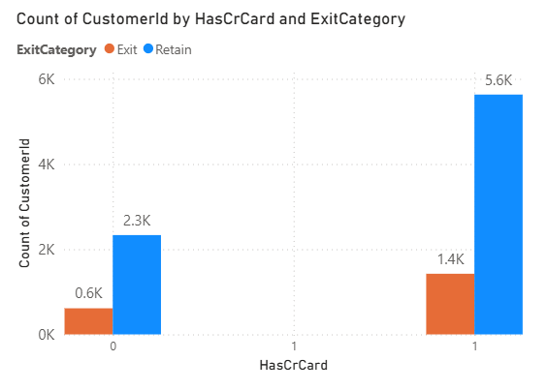
- Credit Card Ownership

2. Number of Products Held
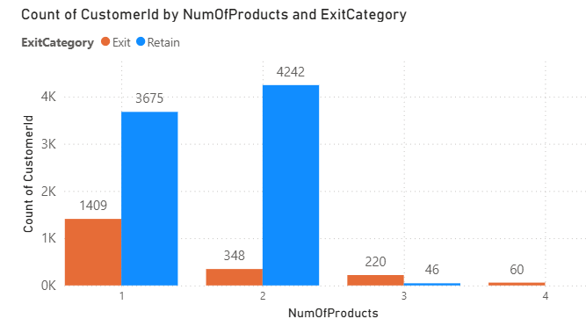
A. Impact of Credit Card Ownership on Exit
Observed Data
Has Credit Card | Exited | Retained | Total
No (0) | 0.6K | 2.3K | 2.9K
Yes (1) | 1.4K | 5.6K | 7.0K
Exit Rate Calculation
- No-Credit-Card:
0.6 / 2.9 ≈ 20.7%
- Has-Credit-Card:
1.4 / 7.0 ≈ 20.0%
Interpretation
- Exit rates are almost identical (~20%).
- Credit card ownership does not significantly influence churn probability.
- Although more churners numerically have credit cards (1.4K), this is due to a larger customer base in that category.
Insight
Credit cards alone are not a strong loyalty driver. Simply offering a credit card does not guarantee long-term retention.

B. Impact of Number of Products on Exit
Observed Data
Products | Exited | Retained | Exit Rate
1 | 1409 | 3675 | 27.7%
2 | 348 | 4242 | 7.6%
3 | 220 | 46 | 82.7%
4 | 60 | ~0 | ~100%

Major Trends Identified
🔴 High Churn Segment 1: Single-Product Customers
- Highest churn volume (1409 exits).
- Exit rate ~28%.
Reasons:
- Low relationship depth
- Easy to switch banks
- Limited engagement
- Low switching cost
These customers likely have only a basic account without deeper integration.

🟢 Most Stable Segment: Two-Product Customers
- Lowest churn rate (~7.6%).
- Highest retention count (4242).
Interpretation:
- Customers are integrated enough to stay.
- Not overwhelmed by complexity.
- Moderate dependency on bank services.

🔴 High Churn Segment 2: 3 or 4 Products
- Extremely high exit rate (82%+ for 3 products).
- Nearly all 4-product customers exited.
Reasons:
- Over-bundling dissatisfaction
- High fees or maintenance charges
- Service complexity
- Poor cross-selling alignment
- Customer fatigue
This is a critical anomaly and requires deeper diagnostic analysis.

C. Common Characteristics of Exited Customers
Based on patterns observed:
1️⃣ Low Engagement Customers
- Hold only one product
- Weak relationship ties
- Higher churn probability
2️⃣ Over-Served or Dissatisfied Customers
- Hold 3–4 products
- Possibly facing higher cost burden
- Likely dissatisfied with bundled offerings
3️⃣ Credit Card Ownership Not a Differentiator
- No major variation in churn probability

D. Behavioral Interpretation
Churn appears driven by relationship imbalance:
- Too little engagement → weak loyalty
- Too much complexity → dissatisfaction
- Moderate engagement (2 products) → highest stability
This suggests a non-linear relationship between product count and retention.

E. Strategic Implications
For 1-Product Customers
- Targeted cross-sell
- Bundle incentives
- Increase engagement touchpoints
For 3–4 Product Customers
- Conduct satisfaction analysis
- Simplify offerings
- Review pricing structure
- Improve service quality
For Credit Card Customers
- Enhance loyalty benefits
- Increase usage incentives
Conclusion:
- The primary trend among customers who exited is imbalanced product engagement rather than credit card ownership.
- Customers holding only one product exhibit high churn due to weak attachment, while customers holding three or more products demonstrate extremely high churn, potentially due to dissatisfaction or service complexity.
- Customers with exactly two products show the strongest retention, suggesting that moderate product integration maximizes customer stability.
Therefore, churn appears to be influenced more by relationship depth and product strategy than by single-product ownership such as credit cards.

8. Are 'Tenure', 'NumOfProducts', 'IsActiveMember', and 'EstimatedSalary' important for predicting if a customer will leave the bank?
To determine whether these variables are important predictors of churn, we analyze their relationship with ExitCategory (Exit vs Retain) using the following charts.
1️⃣ Tenure vs ExitCategory
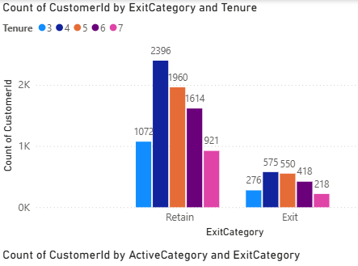
From the tenure distribution chart:
- Retained customers are heavily concentrated around tenure 4–6 years (e.g., 2396 at tenure 4, 1960 at tenure 5).
- Exit customers are also concentrated in similar tenure bands (e.g., 575 at tenure 4, 550 at tenure 5).
Interpretation
- The tenure distribution pattern for Exit and Retain is similar.
- No clear separation between churners and retained customers.
- Exit customers are spread proportionally across tenure groups.
Conclusion
Tenure appears to be a weak-to-moderate predictor. It may contribute slightly to churn prediction but does not independently distinguish churners strongly

2️⃣ NumOfProducts vs ExitCategory
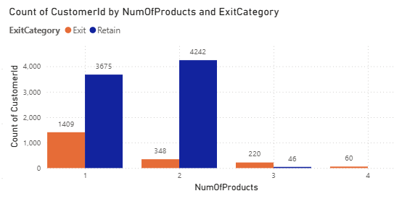
Observations
Products | Exit | Retain | Exit Rate
1 | 1409 | 3675 | ~27.7%
2 | 348 | 4242 | ~7.6%
3 | 220 | 46 | ~82.7%
4 | 60 | ~0 | ~100%
Interpretation
- Customers with 1 product show high churn.
- Customers with 2 products have very low churn.
- Customers with 3 or 4 products show extremely high churn.
This demonstrates a strong nonlinear relationship between number of products and churn.
Conclusion
NumOfProducts is a very strong predictor of churn. It clearly differentiates retained and exited customers.

3️⃣ IsActiveMember vs ExitCategory
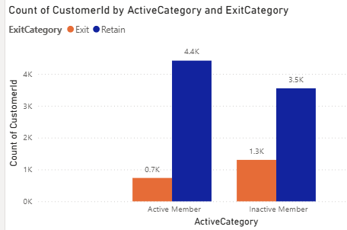

Observations
Active Status | Exit | Retain
Active | 0.7K | 4.4K
Inactive | 1.3K | 3.5K
Exit Rate Approximation
- Active: 0.7 / (0.7 + 4.4) ≈ 13.7%
- Inactive: 1.3 / (1.3 + 3.5) ≈ 27.1%
Interpretation:
Inactive members churn at almost double the rate of active members.
Conclusion:
IsActiveMember is a strong predictor of churn. Customer engagement is highly correlated with retention.

4️⃣ EstimatedSalary vs ExitCategory

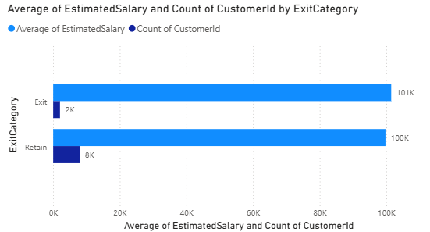

Observations:
- Average salary for Exit ≈ 101K
- Average salary for Retain ≈ 100K
- Very minimal difference.
Interpretation:
Salary distribution between Exit and Retain is almost identical.
Conclusion:
EstimatedSalary is a weak predictor. Income level alone does not significantly influence churn probability.
Conclusion
Among the variables analyzed:
- NumOfProducts and IsActiveMember are highly important predictors of customer churn.
- Tenure shows some influence but does not strongly separate churners from retained customers.
- EstimatedSalary appears to have negligible predictive power.
For churn prediction modeling (e.g., Logistic Regression or Random Forest), priority should be given to:
- NumOfProducts
- IsActiveMember
- Tenure
- EstimatedSalary (low weight)

9.Utilize SQL queries to segment customers based on demographics and account details.
The customers are segmented mainly into three categories based on their estimated salary. They are Low, Medium and High segments. These segments are further divided in female and male customers based on their Geography.
Query:
select GeographyLocation,
case when estimatedsalary < 50000 then 'Low'
when estimatedsalary < 100000 then 'Medium'
else 'High'end as Income_Segment, GenderCategory ,
count(c.customerid) as NumberofCustomers
from customerinfo c
join geography g on c.geographyid = g.geographyid
join gender gn on c.genderid=gn.genderid
group by geographylocation, Income_Segment, GenderCategory
order by geographylocation;

Output:
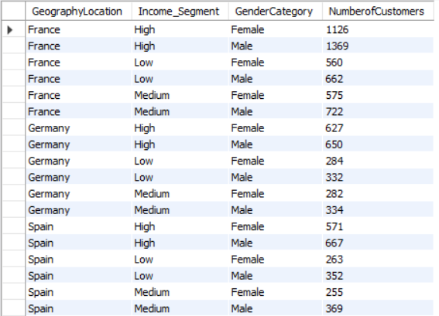

10.How can we create a conditional formatting setup to visually highlight customers at risk of churn and to evaluate the impact of credit card rewards on customer retention?

We can do conditional formatting to visually highlight customers who are at risk of churn and to evaluate the impact of credit card rewards on customer retention in Power BI by the following below steps.

- Create a filter for the "HasCrCard" field. This will allow you to segment customers by whether they have a credit card or not.
- Define the criteria to identify customers at risk of churn. This could be based on a combination of factors, such as:
- Customers with a low number of products purchased (NumOfProducts)
- Customers in Low and Lower Middle Salary segment.
- Customers in Zero and Less 2 Lakh Balance segment.
- Apply a conditional formatting rule to highlight cells that meet the churn criteria. You can format the cells with a different background color or font to make them visually distinct.
- For applying multiple conditions, we have to DAX functions to highlight a cell.
DAX formula Used:
churn risk cust = IF( ( SELECTEDVALUE(Bank_Churn[NumOfProducts]) = 1 &&SELECTEDVALUE(CustomerInfo[SalarySegments])in {"LowSalary","LowerMiddleSalary"}&&SELECTEDVALUE(Bank_Churn[Balance Segments]) in {"Zero","Less 2 lakh"} ), 1 ,0)

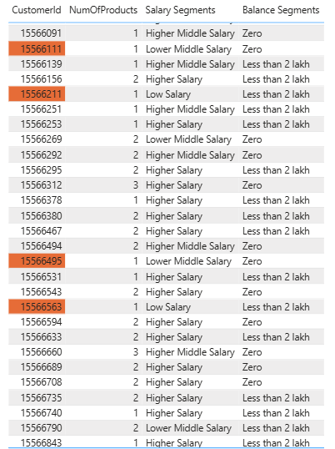
Output:
11.What is the current churn rate per year and overall as well in the bank? Can you suggest some insights to the bank about which kind of customers are more likely to churn and what different strategies can be used to decrease the churn rate?

1️⃣ Overall Churn Rate
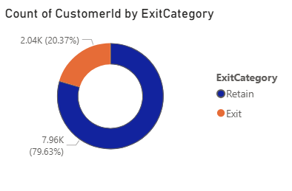
Observation
- Total Customers ≈ 10,000
- Exited Customers ≈ 2,037
- Retained Customers ≈ 7,963
$$\text{Overall Churn Rate}=20.37\%$$
Interpretation
Approximately 1 out of every 5 customers leaves the bank. This level of churn can significantly impact profitability, acquisition costs, and long-term customer lifetime value.

2️⃣ Year-wise / Tenure-Based Churn Rate (Line Chart)
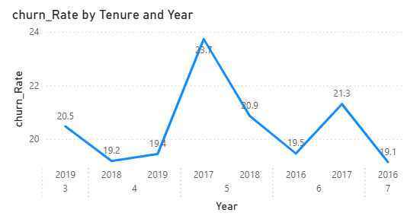

Observed Churn Rates by Tenure:
Tenure (Years) | Churn Rate (%)
3 | 20.5%
4 | 19.2%
5 | 23.7% (Peak)
6 | 19.5%
7 | 19.1%
Interpretation
- Churn peaks at Year 5 (23.7%).
- Indicates mid-lifecycle attrition risk.
- Customers become vulnerable after long-term relationship stabilization.
Strategy
- Introduce loyalty rewards before Year 5.
- Launch proactive engagement campaigns during Years 4–5.
- Offer relationship anniversary benefits.

3️⃣ Balance Segment vs ExitCategory
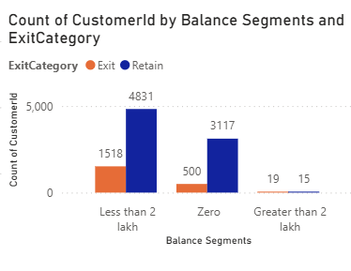
Observations
- Highest churn volume is from customers with Less than 2 lakh balance (1518 exits).
- Zero balance customers also show notable churn.
- Very few customers exist in >2 lakh category.
Interpretation
Lower balance customers:
- Have lower switching costs.
- Show weaker financial attachment.
- Are more price-sensitive.
Strategy
- Introduce balance-linked benefits.
- Reduce minimum balance penalties.
- Offer savings incentives for low-balance customers.

4️⃣ Active Status vs ExitCategory
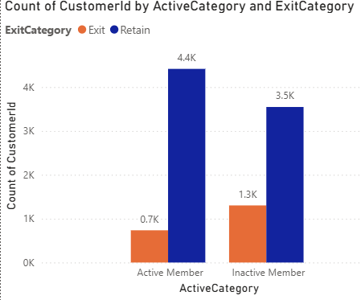

Observations
- Active Members: ~0.7K exited
- Inactive Members: ~1.3K exited
Inactive customers churn nearly 2x more.
Interpretation
Customer engagement is a strong predictor of retention.
Strategy
- Personalized digital notifications.
- Usage-based reward programs.
- Encourage app and service engagement.
- Early churn alert system for inactivity.

5️⃣ Number of Products vs ExitCategory
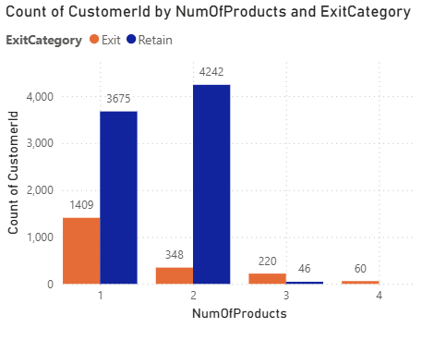
Observations
Products | Exit Rate (Approx.)
1 | ~27.7%
2 | ~7.6%
3 | ~82%
4 | ~100%
Interpretation
- 1-product customers have weak attachment.
- 2-product customers are most stable.
- 3+ product customers show extreme churn (possible dissatisfaction or over-selling).
Strategy
For 1-product customers:
- Cross-sell carefully.
- Bundle complementary services.
For 3+ product customers:
- Conduct satisfaction surveys.
- Simplify pricing structures.
- Review aggressive cross-selling policies.

6️⃣ Credit Score Bucket vs ExitCategory
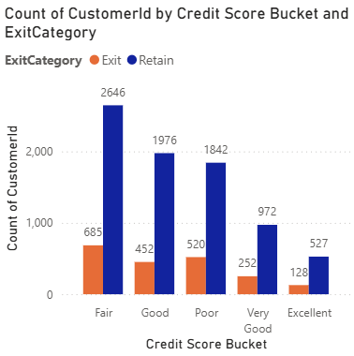
Observations
Higher churn in:
- Fair
- Poor
- Good credit categories
Lower churn in:
- Very Good
- Excellent

Interpretation
Financially vulnerable customers are more unstable and prone to exit.
Strategy
- Flexible repayment options.
- Financial advisory support.
- Risk-adjusted pricing benefits.

Customers Most Likely to Churn
High-risk customers typically are:
- Inactive members
- Customers with only 1 product
- Customers with 3+ products (possible dissatisfaction)
- Customers in Year 5 tenure
- Lower balance holders
- Customers with weaker credit profiles
Churn is primarily driven by:
- Engagement level
- Product structure
- Financial stability

Strategic Framework to Reduce Churn
1️⃣ Engagement Strategy
- Digital engagement campaigns
- Personalized offers
- Activity-based rewards
2️⃣ Lifecycle Retention Strategy
- Pre-Year-5 retention campaigns
- Loyalty bonuses
- Relationship milestone incentives
3️⃣ Product Optimization
- Promote optimal 2-product engagement
- Avoid over-bundling
- Improve service transparency
4️⃣ Risk-Based Retention
- Credit-sensitive financial programs
- Balance-based incentives

Conclusion
The bank’s overall churn rate of 20.37% indicates a significant retention challenge. The highest churn occurs during the 5th year of tenure, and among inactive customers, single-product holders, and financially vulnerable segments.
To reduce churn effectively, the bank must adopt a data-driven, segment-focused retention strategy, emphasizing engagement enhancement, lifecycle-based interventions, balanced product offerings, and targeted financial support.
Implementing predictive churn modeling and proactive retention campaigns will further strengthen customer loyalty and improve long-term profitability.

12. Create a dashboard incorporating all the KPIs and visualization-related metrics. Use a slicer in order to assist in selection in the dashboard.
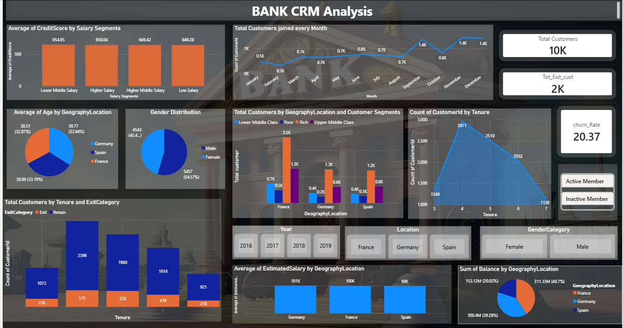

13.How would you approach this problem, if the objective and subjective questions weren't given?
If objective and subjective questions were not provided, the analysis would follow a structured, business-driven exploratory framework. The goal would be to independently identify key insights, risks, and opportunities within the dataset while aligning findings with potential business objectives
Structured Analytical Approach
1️⃣ Business Context Understanding
The first step is to clearly understand the business domain and potential objectives.
- Identify the industry context (e.g., banking, customer retention, risk management).
- Review available documentation, KPIs, and performance metrics.
- Engage stakeholders to understand implicit goals such as churn reduction, profitability improvement, or risk mitigation.
Even without explicit questions, business relevance must guide the analysis.
2️⃣ Exploratory Data Analysis (EDA)
Perform a comprehensive examination of the dataset to uncover structure and patterns.
- Assess data types, completeness, and consistency.
- Analyze distributions of key variables (e.g., tenure, balance, credit score).
- Identify correlations and relationships between features.
- Detect anomalies, missing values, and outliers.
EDA helps surface natural patterns and potential areas of focus such as churn, revenue concentration, or customer segmentation.
3️⃣ Insight Discovery
Based on observed patterns:
- Identify trends (e.g., high churn among inactive customers).
- Detect concentration effects (e.g., revenue concentrated in certain segments).
- Compare segment performance (e.g., product usage vs retention).
This stage converts raw observations into meaningful business insights.
4️⃣ Hypothesis Formulation
From early insights, develop testable hypotheses such as:
- “Customers with fewer products have higher churn probability.”
- “Inactive members are more likely to exit.”
- “Mid-tenure customers show peak attrition risk.”
Hypotheses create analytical direction and allow structured validation using statistical methods.
5️⃣ Advanced Analytical Modeling
Apply appropriate techniques depending on identified patterns:
- Descriptive statistics for trend validation
- Correlation and regression analysis
- Classification models (e.g., churn prediction)
- Segmentation analysis
- Risk modeling
Tools such as SQL, Excel, Power BI, or Python can be used for iterative testing and refinement.
6️⃣ Data Visualization and Storytelling
Translate findings into clear, decision-oriented visuals:
- Trend charts for lifecycle analysis
- Segment comparison charts
- Retention heatmaps
- Risk distribution graphs
Effective visualization improves stakeholder comprehension and supports data-driven decisions.
7️⃣ Synthesis of Findings
Consolidate results into a cohesive narrative:
- Highlight primary risk drivers
- Identify high-value customer segments
- Detect operational inefficiencies
- Quantify business impact
The objective is to move from isolated insights to strategic themes.
8️⃣ Validation and Feedback
Before finalizing conclusions:
- Cross-verify findings through statistical validation.
- Compare results against industry benchmarks.
- Seek stakeholder input to confirm business alignment.
Feedback ensures analytical outputs are actionable and relevant.

Conclusion
In the absence of predefined questions, a systematic, hypothesis-driven approach ensures that analysis remains objective, comprehensive, and aligned with business value.
By combining exploratory analysis, structured modeling, visualization, and stakeholder validation, meaningful insights can be derived even without explicit guidance.
This methodology enhances analytical rigor and ensures that the final outcomes are strategic, actionable, and impactful.

14. In the “Bank_Churn” table how can you modify the name of the “HasCrCard” column to “Has_creditcard”?
Using, “Alter” is a DDL command in SQL.
Code:
alter table Bank_Churn
rename column HasCrCard to Has_creditcard ;
select *
from bank_churn;
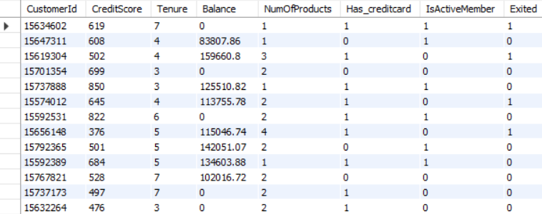
Output:

